**Introduction to Call for Research and Community Service Fund Proposal**

By: **Chalid Luneto.**  October 19, 2020 11:33:18

An Introduction to Call for Research Fund Proposal and Community Service & Discussion on Mainstreaming Gender Equality and Social Inclusion in Research

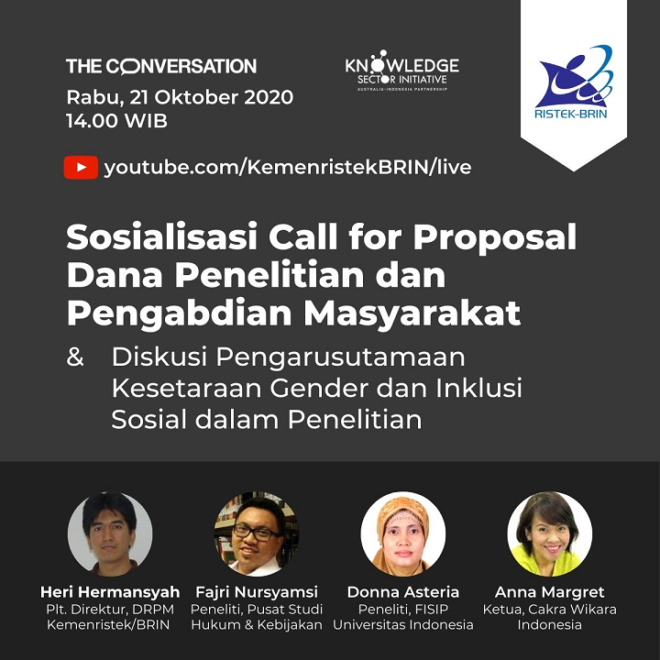

Source: Simlitabmas (October 19, 2020)